25.5 Editors - Properties Editor - Scene Properties Tab
Scene Tab 2
Scene Panel 2
Scene Drop down Box 2
New Scene 2
Delete Scene 3
Camera 3
Background Scene 3
Active Movie Clip 4
Units Panel 4
Unit System 4
Unit Scale 4
Separate Units 4
Rotation 4
Length 4
Mass 4
Time 5
Temperature 5
Gravity Panel 5
Enable 5
Gravity X, Y Z 5
Animate Property 5
Keying Sets Panel 5
Keying Set List 6
Add / Remove Keying Set 6
Description 6
Export to file 6
Active Keying Set 6
Paths 6
Add / Remove Paths 7
Target ID Block 7
Data Path 7
Array all Items 7
FCurve Grouping 7
Keyframe Settings 7
Only Needed 8
Visual Keying 8
XYZ=RGB Colors 8
Audio Panel 8
Volume 8
Animate Property 8
Update Animation Cache 8
Audio Options 8
Distance Model 8
Audio Channels 8
Sample Rate 8
Doppler Speed 8
Doppler Factor 9
Rigid Body World Panel 9
Activate 9
Activate / Remove Rigid Body World 9
Settings 9
Animate Property 9
Collection 9
Constraints 9
Speed 10
Split Impulse 10
Steps Per Second 10
Solver Iterations 10
Cache 10
Simulation Start / End 10
Bake 10
Calculate to Frame 10
Current Cache to Bake 10
Bake All Dynamics 10
Free All Bakes 10
Update All To Frame 10
Field Weights 11
Custom Properties Panel 11
Add 11
Edit 11
Remove 11

Scene Tab
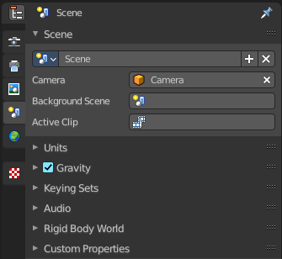
Scenes are a way to organize your work. Usually you work with just one scene. But each. .blend file can contain multiple scenes which share other data, such as objects and materials.

The scenes can be managed in the scene drop down box up right in the header.
Appending happens through the File menu / Append.

Scene Panel

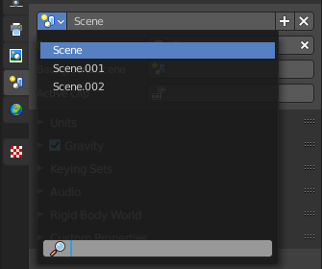
Scene Drop down Box
A list of the available scenes.

New Scene
To add a scene, click on the scene list button, and select Add New.

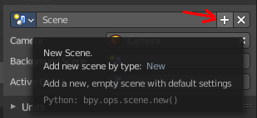
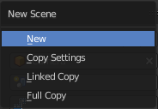

New
Creates an empty scene with default values.

Copy Settings
Creates an empty scene but also copies the settings from the active scene into the new one.

Linked Copy
This option creates a new scene with the same settings and contents as the active scene. However, instead of copying the objects, the new scene contains links to the objects in the old scene. Therefore, changes to objects in the new scene will result in the same changes to the original scene, because the objects used are literally the same. The reverse is also true.

Full Copy
Using this option, nothing is shared. This option creates a fully independent scene with copies of the active scenes contents. Every object in the original scene is duplicated, and a duplicate, private copy of its object-data is made as well.
Note
To choose between these options, it’s useful to understand the difference between Objects and Object Data. See Duplication.
The choices for adding a scene, therefore determine just how much of this information will be copied from the active scene to the new one, and how much will be shared (linked).

Delete Scene
Deletes the currently selected scene.

Camera
Here you can define the active camera for rendering.

Background Scene
Here you can choose a background scene.

Active Movie Clip
Here you can choose an active movie clip for constraints and viewport drawing.

Units Panel

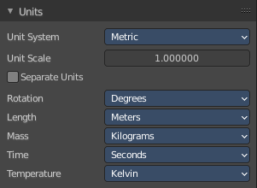
Here you define the units for the scene.

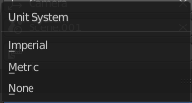

Unit System
The overall unit system that gets used.

Unit Scale
The standard unit scale

Separate Units
Display Units in pairs.

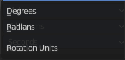
Rotation
Units to display on rotation. Radians or Degree.

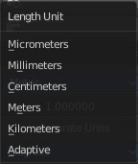
Length
Units to display the length values.

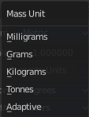
Mass
Units to display the mass values.

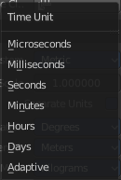
Time
Units to display Time values.

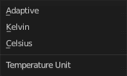
Temperature
Units to display temperature.

Gravity Panel

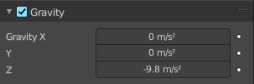
Here you can adjust the gravity settings. The default values are the standard gravity than on earth with the usual acceleration of 9.81 meters per second in Z direction.

Gravity is used for physics simulations like rigid body.

Enable
In the header is a checkbox to enable the gravity.

Gravity X, Y Z
The gravity values.

Animate Property
These properties can be animated. Activating this button sets a keyframe.

Keying Sets Panel
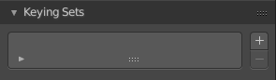

Keying Sets are a collection of properties. They are used to keyframe multiple properties at the same time.
There are some built in Keying Sets, and also custom Keying Sets called Absolute Keying Sets.
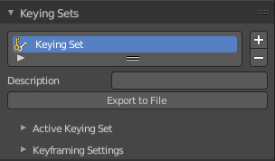
This panel here is used to add, select and manage Absolute Keying sets.
When you add a custom keying set in the list box, then you will reveal further options.

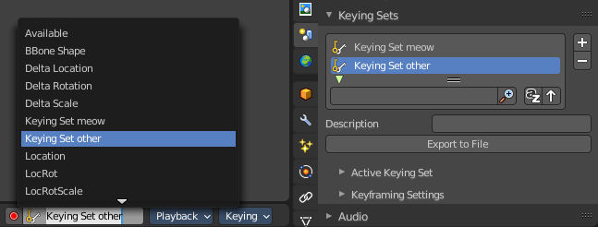
Every keying set that you add here is also available in the list of active keying sets in the header of the timeline editor.

Keying Set List
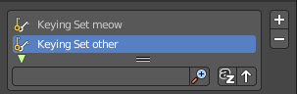
Here you can see the list of your Absolute Keying Sets. The active keying set is highlighted in blue.
It has a search form below the list. Click the arrow button down left to expand the search.
The list display can be resized by clicking at the dotted area and drag it up or down.

Add / Remove Keying Set
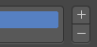
At the right side you can add or remove a keying set with the + and - buttons

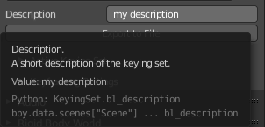
Description
Here you can add a description to your keying set.

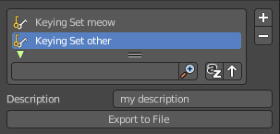
Export to file
Here you can export the keying set to a Python file.
To re add the keying set from the File.py, open then run the File.py from the Text Editor.

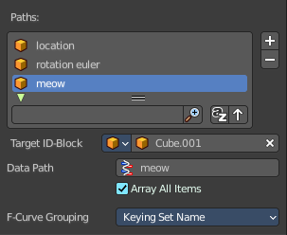
Active Keying Set
Here you can add properties to the active keying set.

Paths
A list with a collection of Paths each with a Data Path to a property to add to the active Keying Set. The active Path is highlighted in blue.
It has a search form below the list. Click the arrow button down left to expand the search.
The list display can be resized by clicking at the dotted area and drag it up or down.

Add / Remove Paths
At the right side you can add or remove a keying set with the + and - buttons

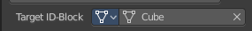
Target ID Block
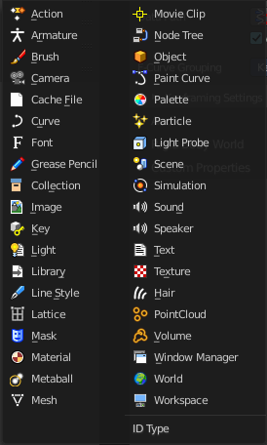
Set the ID-Type + Object ID Data Path for the property. Means pick the object or data type that you want to influence here. When it is a mesh object then you should choose mesh here.
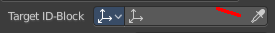
At the left you have a list of the available ID Types. At the right you have a picker as long as you haven't defined the object where you want to use this property at. Use this picker to pick up the object.
Or choose your mesh object from the list of scene objects.

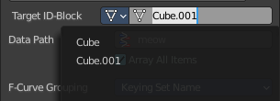

Data Path
Here you can assign a data path variable. This variable points to a python animation property that can be used for the mesh object. Location or rotation euler are valid terms for a mesh object. meow not. It will simply not work. For the available properties for the different object types please have a look in the python API.

Array all Items
For an Array / Vector type, use All Items from the Data Path or select the array index for a specific property.

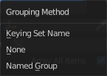
FCurve Grouping
This controls what Group to add the Channels to. Keying Set Name, None, Named Group.

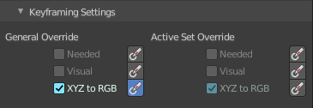
Keyframe Settings
General Override and Active Set Override have the same items each. General override works for all keying sets. Active sets just overrides the current active keying set.
The check boxes activates the item to make it available. The buttons behind sets the item on or off.

Only Needed
Only insert keyframes where they’re needed in the relevant F-Curves.

Visual Keying
Insert keyframes based on the visual transformation.

XYZ=RGB Colors
For new F-Curves, set the colors to RGB for the property set, Location XYZ for example.

Audio Panel
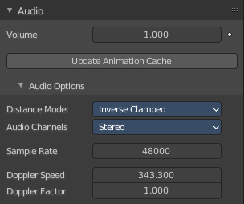
Here you can adjust the general audio settings.

Volume
The Audio Volume.

Animate Property
This property can be animated. Clicking at the button will set a keyframe at the current frame position.

Update Animation Cache
Update the audio animation cache. Something that you might want to do after changes at the settings.

Audio Options

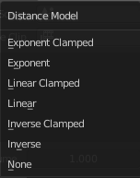
Distance Model
The algorithm for attenuation calculation.

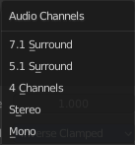
Audio Channels
Audio Channels settings.

Sample Rate
The sample rate for audio playback.

Doppler Speed
Speed of sound for Doppler effect calculation.

Doppler Factor
Pitch factor for Doppler effect calculation.

Rigid Body World Panel

The rigid body world is a group of Rigid Body objects, which holds settings that apply to all rigid bodies in this simulation.
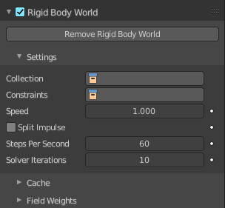
When you add Rigid Body physics on an object, primary there is created a group of objects with default “RigidBodyWorld” name. Rigid body objects automatically are added to this group when you add Rigid Body physics for them.
You can create several Rigid Body World groups, and allocate the Rigid Body objects with Groups panel in Object context.
Rigid body objects and constraints are only taken into account by the simulation if they are in the groups specified in Group field of the Rigid Body World panel in the Scene context.

Activate
In the header is a checkbox where you can enable or disable the Rigid Body World.

Activate / Remove Rigid Body World
Activate or Remove Rigid Body simulation from the current scene.

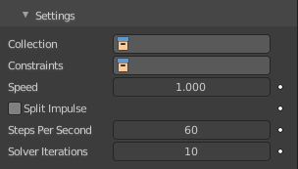
Settings
A sub menu with further settings.

Animate Property
The properties with an animate property at the right can be animated. Clicking at the button will set a keyframe at the current frame position.

Collection
Containing rigid body objects participating in this simulation.

Constraints
Containing rigid body object constraints participating in the simulation.

Speed
Can be used to speed up/slow down the simulation.

Split Impulse
Enable/disable reducing extra velocity that can build up when objects collide (lowers simulation stability a little so use only when necessary). Limits the force with which objects are separated on collision, generally produces nicer results, but makes the simulation less stable (especially when stacking many objects).

Steps Per Second
Number of simulation steps made per second (higher values are more accurate but slower). This only influences the accuracy and not the speed of the simulation.

Solver Iterations
Amount of constraint solver iterations made per simulation step (higher values are more accurate but slower). Increasing this makes constraints and object stacking more stable.

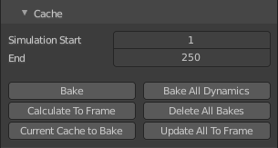
Cache
A sub menu with cache settings. The cache is getting used for animation.

Simulation Start / End
First and last frame of the simulation.

Bake
Calculates the simulation and protects the cache. You need to be in Object mode to bake.

Calculate to Frame
Bake physics to current frame.

Current Cache to Bake
Bake from Cache.

Bake All Dynamics
Bake all physics.

Free All Bakes
Free all baked caches of all objects in the current scene.

Update All To Frame
Update cache to current frame.
If you haven’t saved the blend file, the cache is created in memory, so save your file first or the cache may be lost.

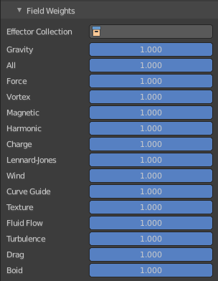
Field Weights
With force fields you can influence rigid body objects in physics simulations. Every force field has its own local settings, which can be adjusted in the physics panel. Here you can adjust the general field weights for those forces.

Custom Properties Panel


Here you can define custom properties that can be used for scripting.

Here you might also find custom properties from addons or scripts.

Add
Adds a new property.


Edit
Opens a panel where you can adjust the settings for the custom property.

Remove
Removes the property.

